**Task 4 for submission**

*Part A addresses* ***Unit Objective 2 - Apply accounting principles and processes relating to accounting and end-of-month reporting for a service business.***

**Part A**

Refer to text book page 201, ex 6.26.

Apply transaction analysis and double entry principles to record the following transactions for Ennis Fuels in the general journal.

Post the general journal entries to the columnar general ledger, then prepare a trial balance at 30 June 2019.

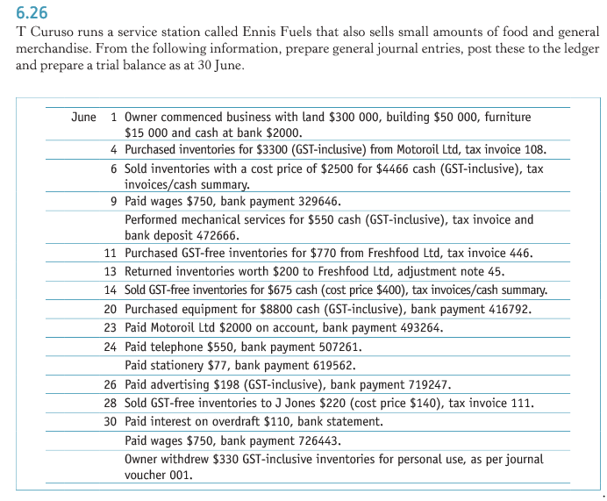

*Part B addresses* ***Unit Objective 1 – Comprehend accounting concepts, principles and processes relating to accounting and end-of-month reporting for a service business.*** *The cognitive verbs* ***describe and explain*** *are components of* ***comprehend*** *ie to show your comprehension of a concept, principle or process, you must describe and explain the concept, principle or process.*

**Part B**

In 150 – 200 word paragraphs:

(a) **describe** internal controls;

Internal control of a business enterprise involves those internal methods and measures that ensure efficient management of the enterprise and achievement of planned objectives. The two types of internal control are accounting controls and administrative controls.

A good system of internal control is necessary to achieve the objective of providing accurate and timely information for decision making and assisting in discharging accountability. It will safeguard assets, check the accuracy and reliability of the business’s accounting data, promote operational efficiency and encourage adherence to prescribed managerial policies.

The general principles of a good system of internal control are:

* Reliable and competent personnel
* Verification – the act of checking the accuracy of accounting records by some independent means eg trial balance, bank reconciliation, stocktakes
* Authorisation – a person in a position of responsibility or authority will validate a course of action eg purchasing assets
* Responsibility
* Separation of duties and rotation of duties – if separation of duties occurs, two or more people would have to collaborate in order to commit a fraud; employees should also rotate duties and be forced to take annual leave
* Adequate and accurate documents and records
* Physical controls and security eg storage of inventories, video surveillance, after-hours security, fire protection, insurance.

(b) **explain** why subsidiary ledgers and control accounts are used to control accounts receivable, accounts payable and inventories *(or* ***explain*** *the interrelationship between subsidiary ledgers, the general ledger and control accounts).*

As the number of accounts receivable and accounts payable increase, the volume of transactions recorded in the general ledger can become cumbersome. The increase in transaction results in excessive detail being present in the general ledger. A major aim of the accounting process is to take repetitive information out of the general ledger. A technique for deleting unnecessarily detailed information from the general ledger is the use of control accounts and subsidiary ledgers.

Subsidiary ledgers are additional ledgers maintained for the specific purpose of holding all individual accounts receivable or accounts payable accounts. Individual inventory item movements are recorded in stock cards.

One replacement control account for each subsidiary ledger is required in the general ledger. One inventories control account in the general ledger summarises the total of all information contained in all stock cards.

Control accounts are general ledger accounts that summarise like transactions in either the individual subsidiary ledger accounts or stock cards.

If detail is removed from the general ledger, then double entry is affected. Therefore a summary (control account) to replace the removed detailed accounts is required.